**User Registartion API**

Register a user with First Name, Last Name, Email ID, Password, a unique employeeID and Organization Name.

URL:- http://localhost:3000/api/user/register

{

    "firstName": "Sarita",

    "lastName": "yadav",

    "emailId": "sarita@gmail.com",

    "password": "sarita",

    "empID": "4568",

    "orgName": "sarita"

}

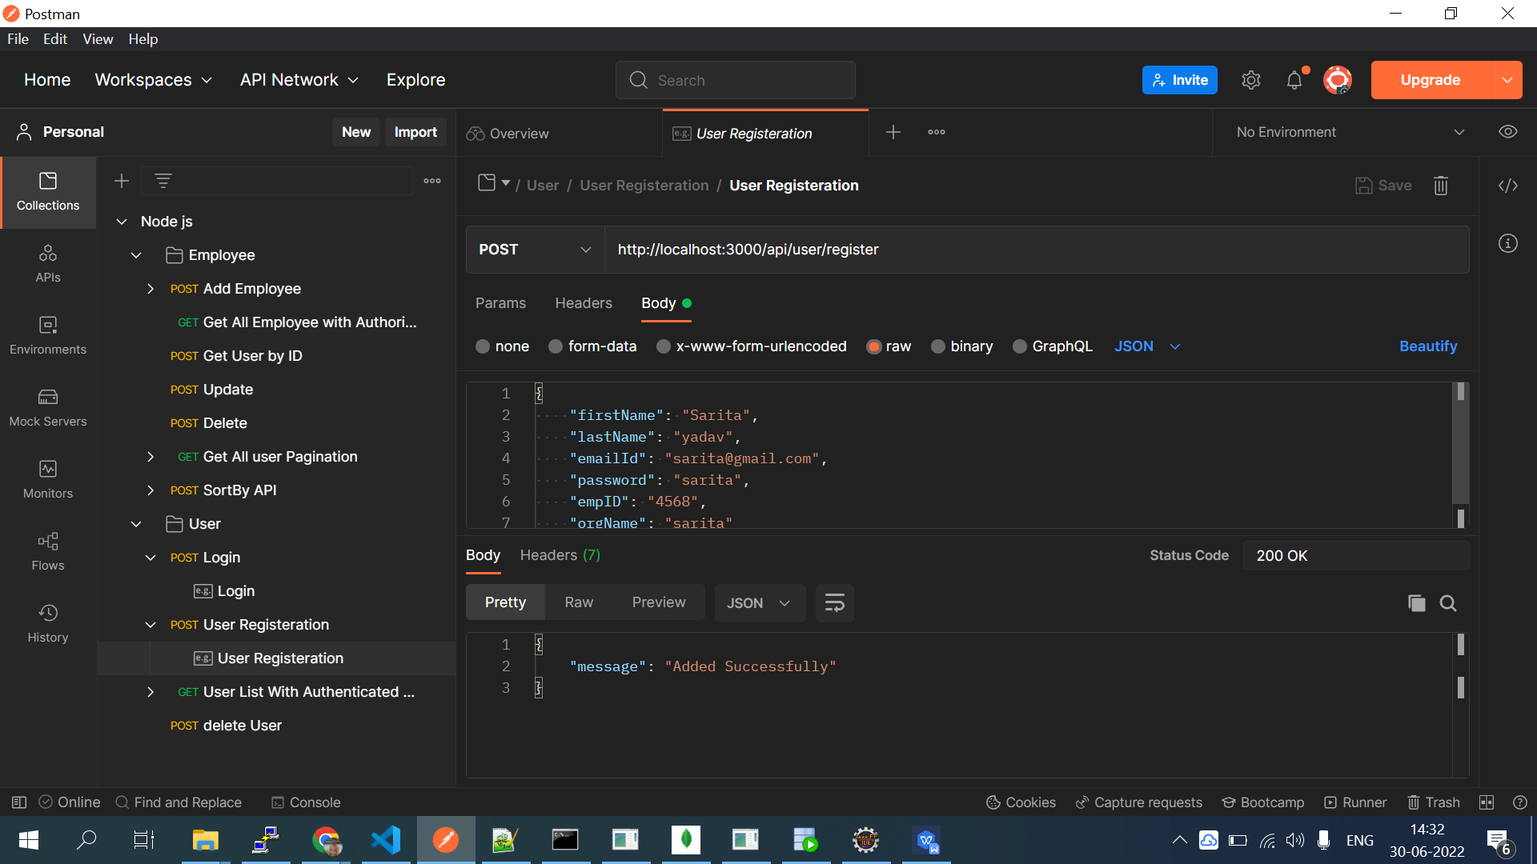

**User Login API Getting Access Token**

Login Email ID and Password

Url:- http://localhost:3000/api/user/login

{

    "emailId":"sarita@gmail.com",

    "password":"sarita"

}

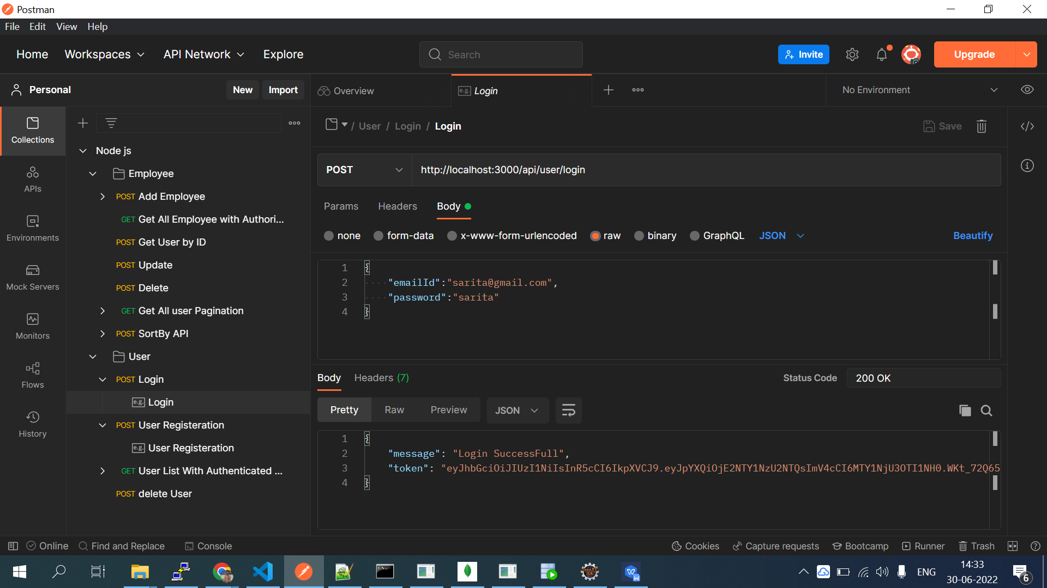

**UserList API**

Use a proper authentication mechanism for securing userList endpoints

Url:- http://localhost:3000/api/user/userlist

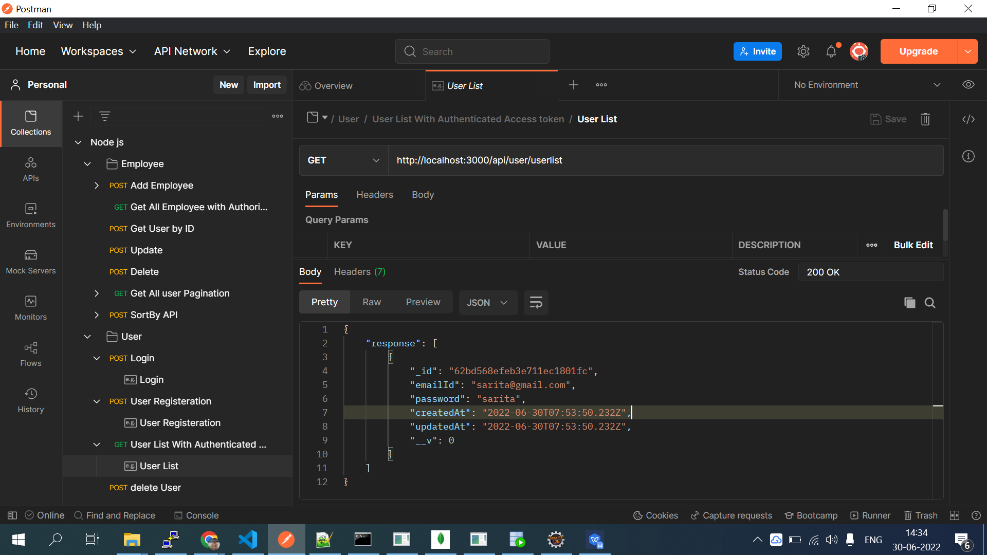

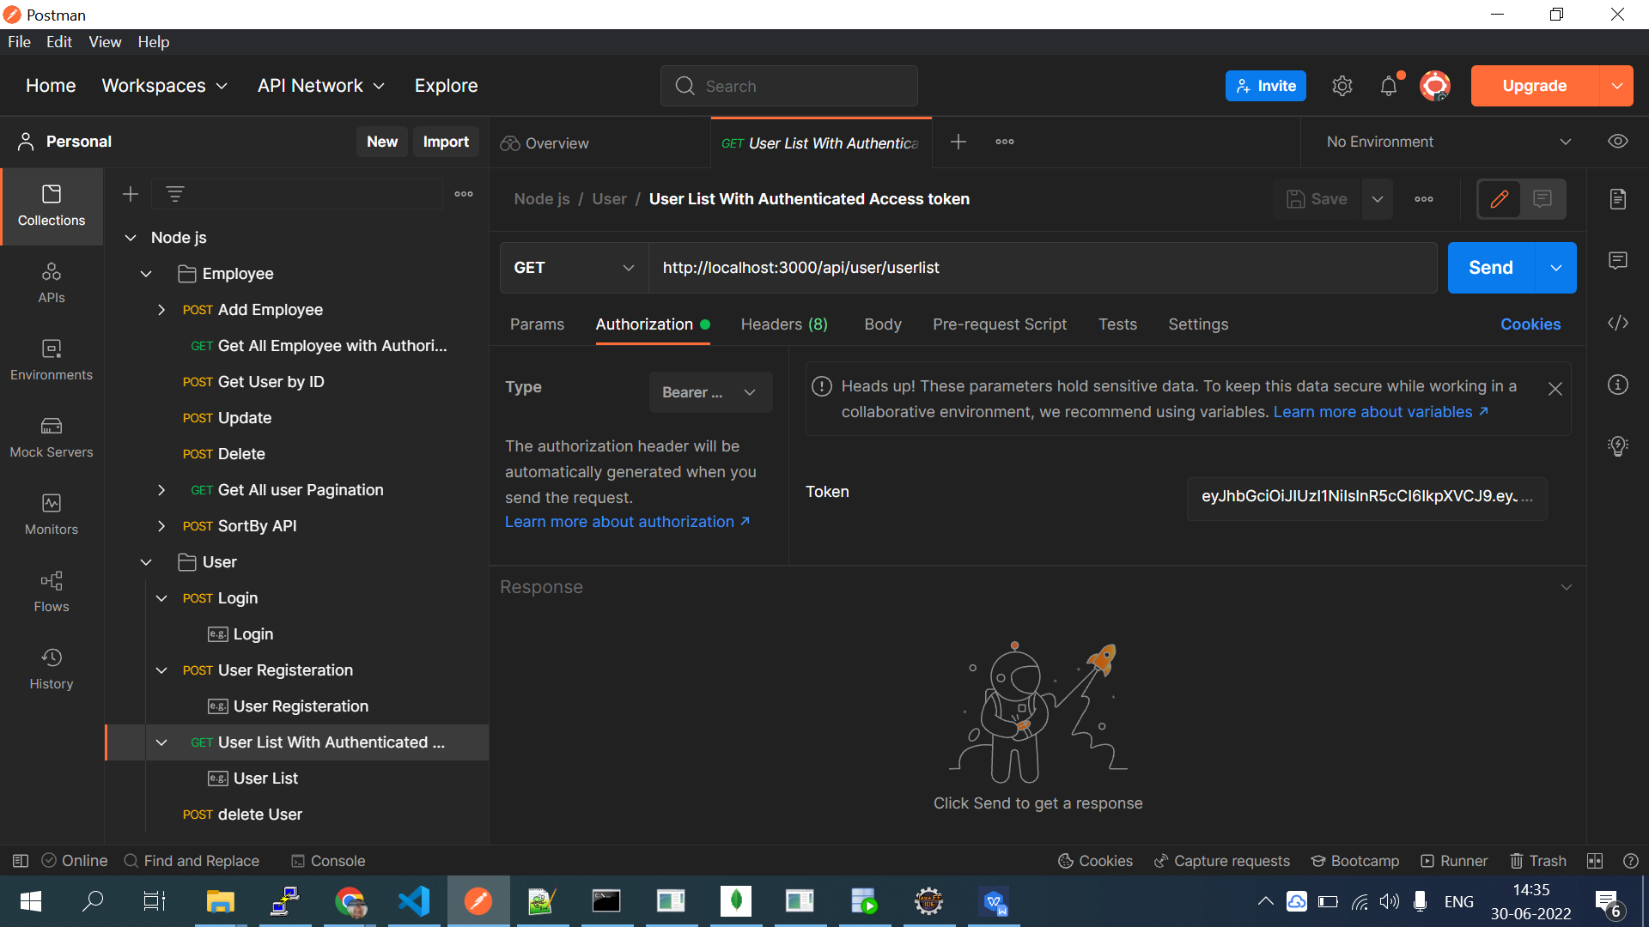

**Sort BY API**

Sort data by First Name, Last Name, Email ID, employeeID and Organization Name

Url:- http://localhost:3000/api/employee/filter?sortBy=firstName

{

    "response": [

        {

            "_id": "62bd55c22633d27aa07f2785",

            "empID": "42365",

            "firstName": "ASarita",

            "lastName": "A",

            "emailId": "asarita@gmail.com",

            "orgName": "asarita",

            "createdAt": "2022-06-30T07:50:26.341Z",

            "updatedAt": "2022-06-30T07:50:26.341Z",

            "__v": 0

        },

        {

            "_id": "62bd557e2633d27aa07f2783",

            "empID": "12345",

            "firstName": "Sarita",

            "lastName": "yadav",

            "emailId": "sarita@gmail.com",

            "orgName": "sarita",

            "createdAt": "2022-06-30T07:49:18.097Z",

            "updatedAt": "2022-06-30T07:49:18.097Z",

            "__v": 0

        },

        {

            "_id": "62bd55d12633d27aa07f2787",

            "empID": "963",

            "firstName": "bSarita",

            "lastName": "b",

            "emailId": "bsarita@gmail.com",

            "orgName": "bsarita",

            "createdAt": "2022-06-30T07:50:41.384Z",

            "updatedAt": "2022-06-30T07:50:41.384Z",

            "__v": 0

        },

        {

            "_id": "62bd33d87f5e3d023345b61a",

            "empID": "1234",

            "firstName": "mallah",

            "lastName": "yadav",

            "emailId": "sarita@gmail.com",

            "orgName": "sarita",

            "createdAt": "2022-06-30T05:25:44.830Z",

            "updatedAt": "2022-06-30T05:25:44.830Z",

            "__v": 0

        },

        {

            "_id": "62bd34147f5e3d023345b61d",

            "empID": "12345",

            "firstName": "mallah",

            "lastName": "yadav",

            "emailId": "sarita@gmail.com",

            "orgName": "sarita",

            "createdAt": "2022-06-30T05:26:44.599Z",

            "updatedAt": "2022-06-30T05:26:44.599Z",

            "__v": 0

        },

        {

            "_id": "62bd2d57fbae057cf44a82fd",

            "empID": "1234",

            "firstName": "sarita",

            "lastName": "yadav",

            "emailId": "sarita@gmail.com",

            "orgName": "sarita",

            "createdAt": "2022-06-30T04:57:59.818Z",

            "updatedAt": "2022-06-30T04:57:59.818Z",

            "__v": 0

        },

        {

            "_id": "62bd2d58fbae057cf44a82ff",

            "empID": "1234",

            "firstName": "sarita",

            "lastName": "yadav",

            "emailId": "sarita@gmail.com",

            "orgName": "sarita",

            "createdAt": "2022-06-30T04:58:00.664Z",

            "updatedAt": "2022-06-30T04:58:00.664Z",

            "__v": 0

        },

        {

            "_id": "62bd2d59fbae057cf44a8301",

            "empID": "1234",

            "firstName": "sarita",

            "lastName": "yadav",

            "emailId": "sarita@gmail.com",

            "orgName": "sarita",

            "createdAt": "2022-06-30T04:58:01.419Z",

            "updatedAt": "2022-06-30T04:58:01.419Z",

            "__v": 0

        }

    ]

}

Passing access token in Header for filter API

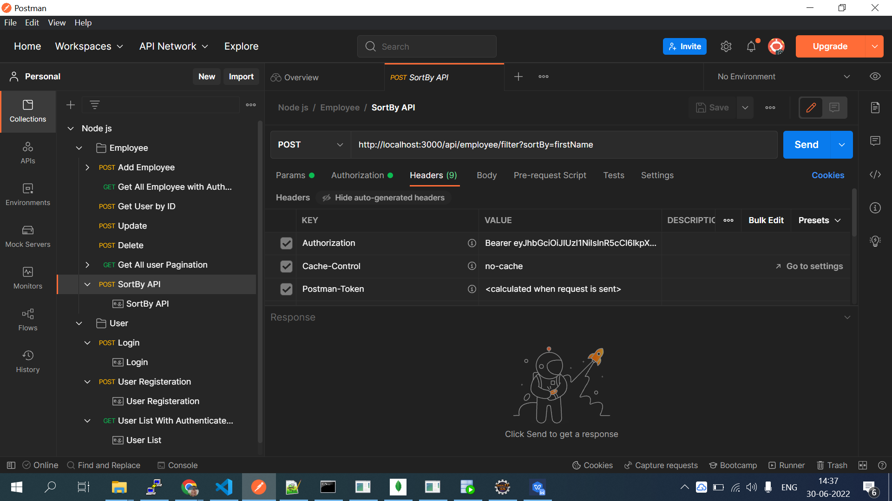

**Pagination API**

Url:- http://localhost:3000/api/employee?page=1&limit=2

{

    "response": {

        "docs": [

            {

                "_id": "62bd2d57fbae057cf44a82fd",

                "empID": "1234",

                "firstName": "sarita",

                "lastName": "yadav",

                "emailId": "sarita@gmail.com",

                "orgName": "sarita",

                "createdAt": "2022-06-30T04:57:59.818Z",

                "updatedAt": "2022-06-30T04:57:59.818Z",

                "__v": 0

            },

            {

                "_id": "62bd2d58fbae057cf44a82ff",

                "empID": "1234",

                "firstName": "sarita",

                "lastName": "yadav",

                "emailId": "sarita@gmail.com",

                "orgName": "sarita",

                "createdAt": "2022-06-30T04:58:00.664Z",

                "updatedAt": "2022-06-30T04:58:00.664Z",

                "__v": 0

            }

        ],

        "totalDocs": 8,

        "limit": 2,

        "totalPages": 4,

        "page": 1,

        "pagingCounter": 1,

        "hasPrevPage": false,

        "hasNextPage": true,

        "prevPage": null,

        "nextPage": 2

    }

}

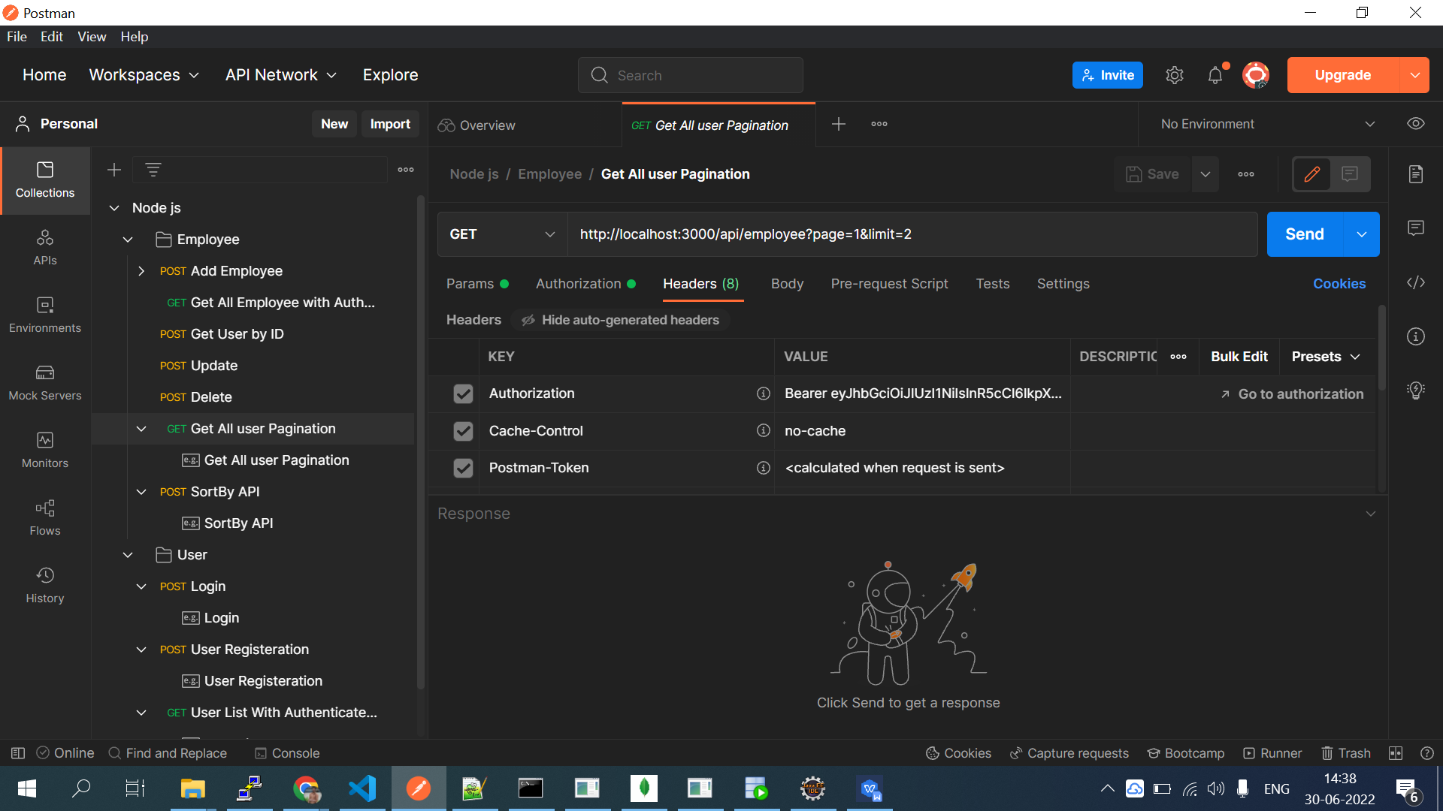

I am Including All API request and sample response as exported Json from Postman